Flag Semaphore Signals

*Flag semaphore* is the telegraphy system conveying information at a distance by means of visual signals with hand-held flags, rods, disks, paddles, or occasionally bare or gloved hands. Information is encoded by the position of the flags; it is read when the flag is in a fixed position. Semaphores were adopted and widely in the maritime world in the 19th century.

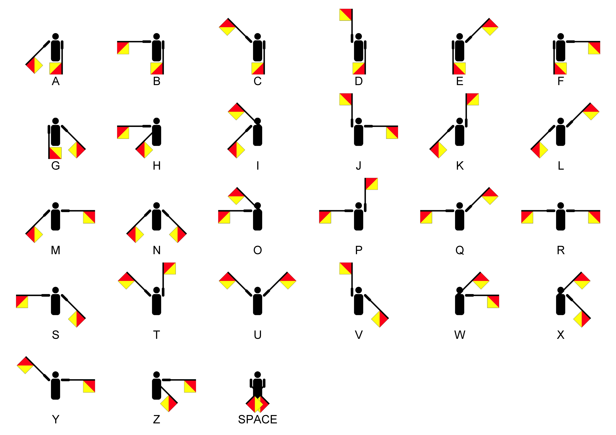

Text and image source: Wikipedia